**Name-Ujjawal Mandhani**

**Batch-F6**

**Enroll No.-9918103237**

**OSS Lab-4**

**Question 1:**Using numpy, WAP that takes an input from the user in the form of a list and calculate the frequency of occurrence of each character/integer in that list (count the number of characters).

**import numpy as np**

**a = np.array([10, 10, 20, 10, 20, 20, 20, 30, 30, 50, 40, 40])**

**print("Original array:")**

**print(a)**

**unique_elements, counts_elements = np.unique(a, return_counts=True)**

**print("Frequency of unique values of the said array:")**

**print(np.asarray((unique_elements, counts_elements)))**

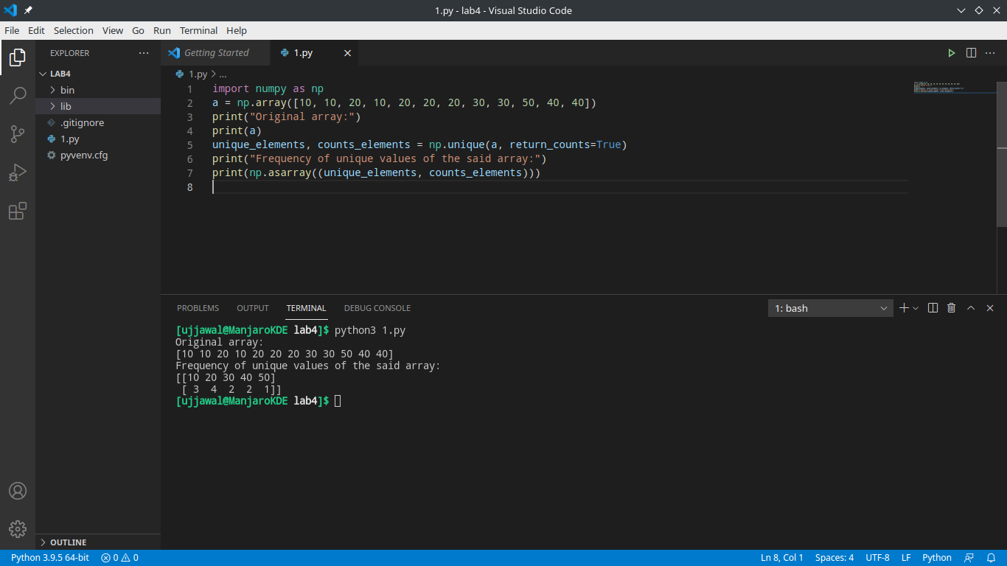

**Question2:**Take a binary input form user and segregate all 1&#39;s to left side and 0&#39;s to right side.

Ex: Input : 1010011 Output : 111100

**def segregate0and1(arr, size):**

**left, right = 0, size-1**

**while left < right:**

**while arr[left] == 0 and left < right:**

**left += 1**

**while arr[right] == 1 and left < right:**

**right -= 1**

**if left < right:**

**arr[left] = 0**

**arr[right] = 1**

**left += 1**

**right -= 1**

**return arr**

**arr = [0, 1, 0, 1, 1, 1]**

**arr_size = len(arr)**

**print("Array after segregation")**

**print(segregate0and1(arr, arr_size))**

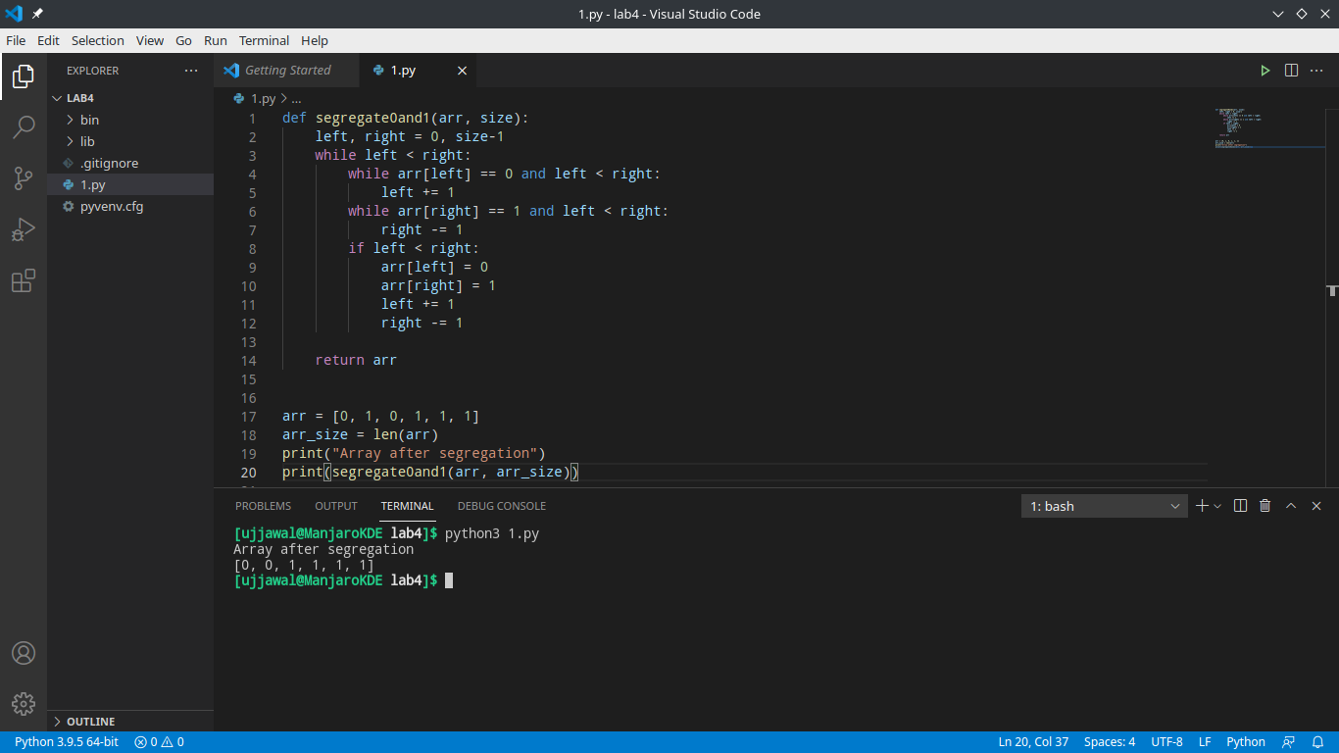

**Question 3:**Write a Python program to remove the nth index character from a nonempty string.

**def remove_char(str, n):**

**first_part = str[:n]**

**last_part = str[n+1:]**

**return first_part + last_part**

**print(remove_char("Ujjawal", 0))**

**print(remove_char("Mandhani", 1))**

**print(remove_char("Python", 5))**

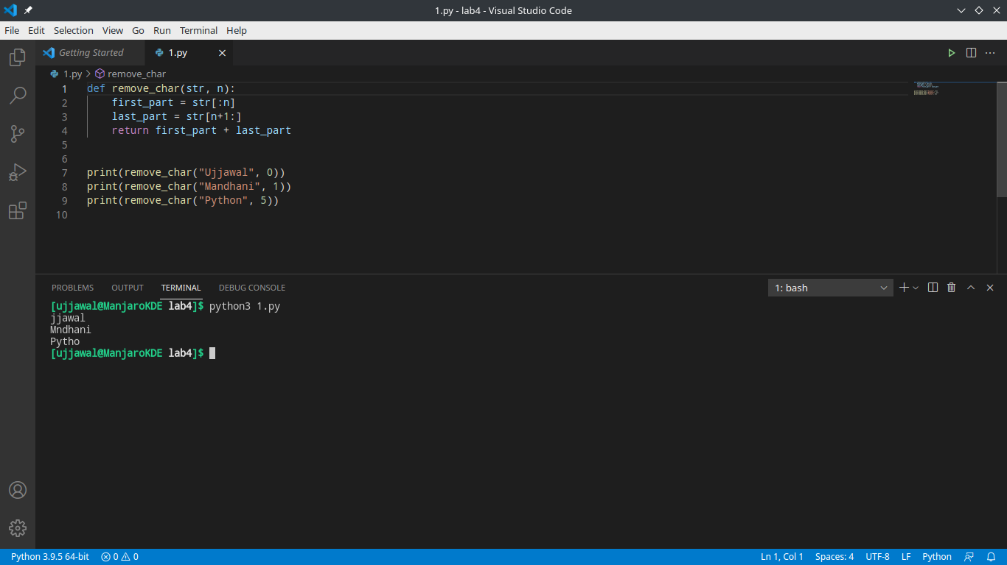

**Question 4:**Write a Python program to test whether each element of a 1-D array is also present in a

second array.

Expected Output:

Array1: [ 0 10 20 40 60]

Array2: [0, 40]

Compare each element of array1 and array2

[ True False False True False]

**import numpy as np**

**array1 = np.array([0, 10, 20, 40, 60])**

**print("Array1: ", array1)**

**array2 = [0, 40]**

**print("Array2: ", array2)**

**print("Compare each element of array1 and array2")**

**print(np.in1d(array1, array2))**

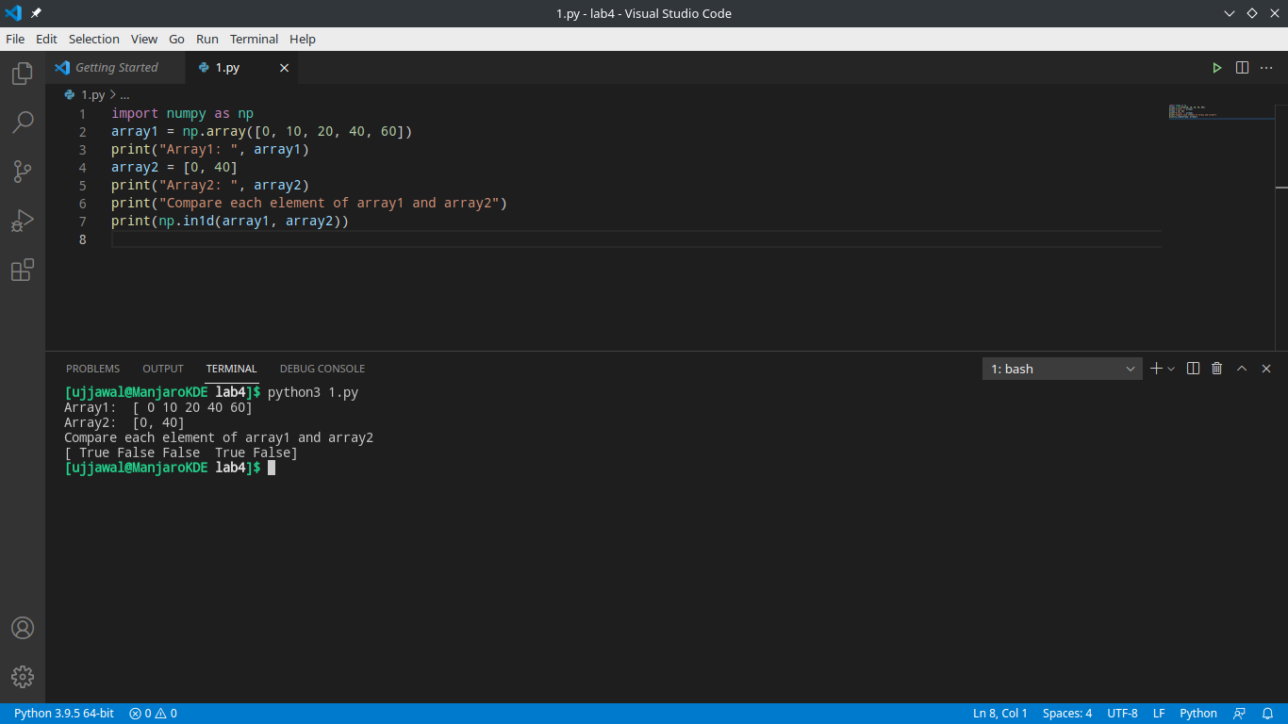

**Question 5:**Write a Python program to find the set exclusive-or of two arrays. Set exclusive-or will

return the sorted, unique values that are in only one (not both) of the input arrays.

Array1: [ 0 10 20 40 60 80]

Array2: [10, 30, 40, 50, 70]

Unique values that are in only one (not both) of the input arrays:

[ 0 20 30 50 60 70 80]

**import numpy as np**

**array1 = np.array([0, 10, 20, 40, 60, 80])**

**print("Array1: ", array1)**

**array2 = np.array([10, 30, 40, 50, 70])**

**print("Array2: ", array2)**

**print("Unique values that are in only one (not both) of the input arrays: ")**

**print(np.setxor1d(array1, array2))**

